Shabbos Stories for
Parshas shemos 5784
Volume 15, Issue 17 25 Teves 5784/January 6, 2024
Printed L’illuy nishmas Nechama bas R’ Noach, a”h
For a free subscription, please forward your request to keren18@juno.com
Past emails can be found on the website – ShabbosStories.com

A Recent Exodus from Egypt
By Dr. Jack Cohen

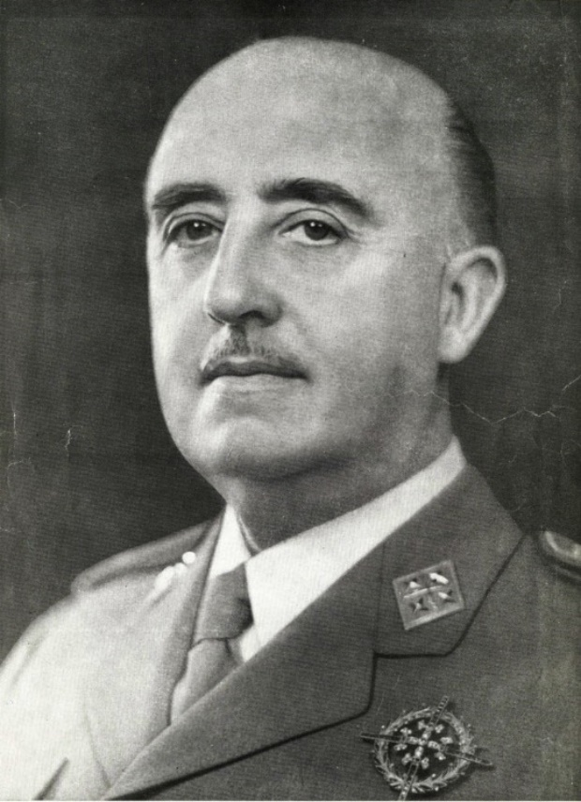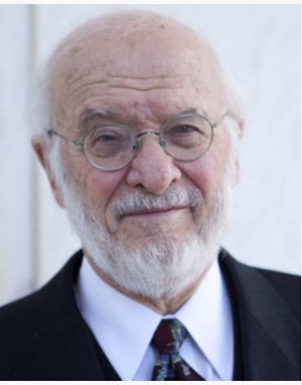
Francisco Franco Nathan Lewin

My father’s family was originally from Syria. They migrated to Yerushalayim and then to Cairo [in Egypt]. My mother’s father was born and raised in Odessa, Ukraine. He ran away as a refugee after the communists took over Russia to the northern coast of Africa in Cairo, where he married a local Sephardic woman.
My parents met in Cairo and we were raised in Egypt. Interestingly, my father was considered Sephardi and my mother Ashkenazi. We experienced a very nice life until the Six-Day War. Jews were being persecuted, which made it difficult to live there.
All the Jewish Males Were Put in Jail by Nasser
My father and all other Jewish males were put in jail by the dictator of Egypt, Gamal Nasser. Nasser was furious and wanted revenge because when the war had broken out, the IDF had miraculously destroyed all of the Egyptian planes. His way of revenge was to arrest all of the Jewish males and concoct some story in an attempt to execute all of them. But miraculously they were saved.
I’ll tell you the interesting background story. After the Six-Day War broke out and the Jews were incarcerated, there was a lead story in The New York Times that they were going to be executed. The Rosh HaYeshiva [Rabbi Shrage Moshe Kalmanowitz, zt”l] of the Mirrer Yeshiva of Brooklyn saw the Times story and he called up the United States State Department furiously arguing what the government should do about that.
Interestingly, the person who answered the phone, Nathan Lewin, was a law clerk and a law student at Harvard University. When the rabbi called him up, he was clueless as to what to do. It was erev Shabbos, Friday afternoon, and Mr. Lewin began driving to Virginia where he was living. Suddenly, a Virginia State patrol officer pulls him over and tells him that the State Department was looking for him and he needs to return to them because a rabbi keeps calling from New York and they don’t know what to do. Mr. Lewin went back to the State Department and his supervisor asked him what they should do since the rabbi keeps calling.
Suddenly Mr. Lewin came up with a brilliant idea. He had read somewhere that the fascist dictator of Spain, [General Francisco] Franco, had tremendous remorse for what happened to the Jews in Spain during the Spanish Inquisition and he felt bad about it and was looking to make amends for that. Jumping on that thought, Mr. Lewin said he would like to call him.

A Phone Call to General Franco
He called him and said, “We have a serious crisis with all the Jewish people in Egypt. They’re being threatened with physical annihilation. Would you, sir, go ahead and issue passports to them that will immediately make them Spanish citizens which will give them the freedom to leave the country?” They were all issued Spanish passports, including my father. We quickly got our luggage and found our father waiting for us on a big freight boat going to Barcelona. From there we were routed to Paris and ultimately to the United States. That’s a bit of an interesting story that shows you that the Jewish people have Hashem looking over them and as a result it’s He who keeps us alive and He who maintains our existence.

Reprinted from the December 22, 2023 Jewish Press website.
A Peculiar Blessing
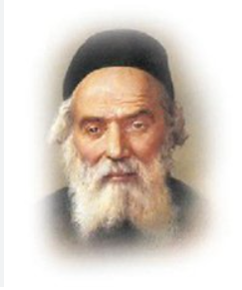
The Hafess Hayim called his wagon driver into his study. “I understand that you are traveling to Salant. Please speak to R’ Yosef Zundel,” the Hafess Hayim requested. “Ask him for a blessing on my behalf.” R’ Yosef Zundel was famous throughout Lithuania for his vast Torah knowledge and piety. His blessings were valued and treasured by some of the greatest names in the Torah world.
The wagon driver duly went to R’ Yosef Zundel’s home and asked, in the name of the Hafess Hayim, for a blessing. R’ Yosef Zundel thought for a moment, then replied, “May it be Hashem’s Will that you walk barefoot and bear stones!”
The wagon driver was shocked. This was the prized blessing that the Hafess Hayim had wanted? R’ Yosef Zundel’s words seemed so strange, so utterly bizarre, that the man thought it would be wiser not to mention them to the Hafess Hayim at all. He returned to Radin and went about his business, avoiding the Hafess Hayim entirely.
A day later, he received a summons from the Hafess Hayim. “I see you have returned from Salant,” the Hafess Hayim said. “Why haven’t you brought me an answer from R’ Yosef Zundel?”
“Rebbe,” the wagon driver stammered, “I went to R’ Yosef Zundel, but he - he didn’t make sense! I couldn’t pass on a blessing like that!”
“Why not let me judge for myself?” the Hafess Hayim gently suggested.
The wagon driver, embarrassed to repeat R’ Yosef Zundel’s peculiar blessing, muttered, “He said that Hashem should bless you to walk barefoot, and to bear stones.”
The Hafess Hayim smiled. “Ah, what a blessing!” he sighed. “May it come true very soon…And it would be enough to walk barefoot, without bearing stones as well!”
His family asked, “How could this be a good blessing? What does it mean?”
“Why, it’s simple,” the Hafess Hayim explained. “As you know, I am a Kohen. R’ Yosef Zundel blessed me that I should soon merit to serve Hashem in the Bet Hamikdash, where the Kohanim walked barefoot as they performed their duties. He also blessed me that I should merit to serve as Kohen Gadol, and bear the twelve stones of the hoshen; but as for me, I would be content to be ‘merely’ a Kohen, and serve Hashem in His Holy Temple - may it be rebuilt speedily, in our days!” (Taryag Tales)

Reprinted from the Parashat Vayigash 5784 email of Rabbi David Bibi’s Shabbat Shalom from Cyberspace.

The Difficult Segula for
the Childless Chassid

There was once a Chasid who travelled to his Rebbe every month to take in the atmosphere of holiness which filled the very air of Kozhnitz. He was happy with his lot in life; if only he had a child, he would be completely content.
Several times his wife had insisted that he ask the Rebbe for a blessing to cure their childlessness, but to no avail. His wife wouldn’t desist from her pleas. “This time,” she insisted, “you must not leave the holy Rebbe until he answers our request, for my life is worthless to me without children.”

“Are You Willing to Become a Pauper?”
The man was forced to agree, and when he came to Kozhnitz and was admitted into the Rebbe’s chambers, he told the Rebbe of their longing for a child. The Rebbe listened and offered him the solution his spiritual vision afforded him: “If you are willing to become a pauper you will be granted the blessing you seek.” The man agreed to discuss the condition with his wife and return with her answer.
The woman didn’t think for a moment. “Of course, it’s worth everything to me. What good is wealth without children?” The man returned to Kozhnitz and accepted the harsh prescription. But poverty was not the end of the Rebbe’s advice; the man was sent on a long arduous journey to visit the famous tzadik, the Chozeh (Seer) of Lublin.
The Chozeh was known for his power to discern the state and provenance of a person’s soul, and when he met the Chasid he studied his visitor long and hard before he spoke.

Explaining the Source of Chasid’s Childlessness
“I will tell you the source of your childlessness and then what you must do to correct the problem. Once, when you were very young, you promised to wed a certain maiden.
When you matured, she didn’t interest you any longer and you broke your promise and left the place. Since she was your true intended, you have not been able to have children since. You must find her and beg her forgiveness. Go to the city of Balta which is very distant from here -- there you’ll find the woman.”
The Chasid wasted no time in embarking on the journey. But when he arrived there no one knew anything about the woman. He rented a room and waited to see the words of the tzadik materialize.
One day, he was walking down the street when he was caught in a sudden downpour. He ran to a nearby shop to escape from the rain and found himself standing near two women who were also seeking shelter. Suddenly, he was shocked to hear one say to the other, “Do you see that man? He was once betrothed to me in my youth and deserted me!” He turned to see a woman dressed in the richest fabrics and wearing beautiful and valuable jewels.

“Don’t You Remember Me?”
He approached her and she said, “Don’t you remember me? I am the one you were engaged to so many years ago. Have you any children?”
He immediately poured out the entire story, telling her that he had come only to find her and beseech her to forgive him. He begged her to ask of him anything to atone for the terrible pain he had caused her.
“I lack nothing, for G-d has provided me with all I need, but I have a brother who is in desperate need. Go to him and give him 200 gold coins with which he can marry off his daughter, and I will forgive you. In the merit of marrying off a poor bride you will be blessed with children, as the tzadik told you.”
“Please, you give your brother this money. I have travelled many months and I’m very anxious to return home.”
“No,” the woman adamantly refused. “I am not able to travel now, and it is not feasible to send such a sum of money. No, you must go yourself.” With that, she turned and proceeded down the street, but as he was following her with his eyes, she seemed to disappear.
The Chasid ventured on yet another journey to a distant city where he was able to locate the woman’s brother.
The man was in a terrible state of agitation which he readily explained: “My daughter is betrothed to a wealthy young man, but I have suddenly become penniless and unless I can find the dowry money, the marriage is off.”
The Chasid listened to the heartrending tale and then said: “I will give you two hundred gold coins which will be more than enough for all your expenses.” The man couldn’t believe his ears. “What, you don’t even know me -- why would you do such a thing for a total stranger?”
“I have been sent by your sister whom I met a few weeks ago in Balta. Many years ago, I was once betrothed to her and I abandoned her, and the help I’m offering to you is my promise to her.”
“What are you saying?” the man turned pale. “What kind of crazy tale are you spinning and why? My sister has been dead for fifteen years. I should know -- I buried her myself!”
Now it was time for the Chasid to be shocked. It was beginning to dawn on him that the Maggid of Kozhnitz and the Chozeh of Lublin had orchestrated this entire wondrous episode for his good and the good of this man. He handed him the golden coins and the man blessed him to be granted the blessing of many sons and daughters and a long and happy life of joy from them.

Reprinted from the Parshas Vayechi 5784 edition of L’Chaim, a publication of the Lubavitch Youth Organization in Brooklyn, NY.

Choosing to Embarrass Himself in Public
By Rabbi Reuven Semah

Rabbi Ephraim Nisenbaum tells a great story about how far one should go to avoid shaming someone. The Rebbe Reb Heshel of Krakow was engaged to the daughter of a wealthy man who promised to support the young genius so he could devote all his time to his studies. Shortly before the wedding, Reb Heshel and his parents visited his kallah’s town. As they neared her house, Reb Heshel saw the young woman busily preparing a gourmet meal for her hattan and his family. Suddenly, a chicken hopped on the table and ruined the food.

Quickly Ran to a Nearby Shul
Not realizing she was being watched, the distraught young woman grabbed the chicken and hit it against the wall. Rav Heshel was stunned and decided he could not marry a person with such character. However, he could not embarrass her family by breaking the engagement so close to the wedding. Thinking quickly, Reb Heshel ran to the nearby shul, leaving his parents perplexed. In shul, he clumsily began banging on the sedakah pushka connected to the wall, trying to open it.
A few people recognized the young hattan and quickly ran to the prospective father-in-law and related that they had seen the young man trying to steal from the pushka. The man was furious and immediately informed his daughter that her groom was a thief. The family decided to break the engagement. Later, when Reb Heshel’s father asked him why he had done such a thing, the young man told his father what he had seen and why he could not marry the young woman. He had decided to take the embarrassment himself rather than embarrass the kallah and her family.

Reprinted from the Parashat Vayigash email of the Jersey Shore Torah Bulletin.

Becoming Rebbe in Shpoleh

There are various versions as to how the Zeide finally became publicly known as a tzaddik and miracle worker.
HaRav Yosef Yitzchok of Lubavitch, known as the Frierdiker Rebbe, related the following incident:
Once, on his way to visit the Maggid of Mezritch,^{[1]} Reb Yehudah Leib noticed a Jew struggling to pull his wagon out of some deep mud. When the Jew noticed him coming down the road, he called out to him and requested that he help him.
“I am unable to pull out the wagon,” he replied, “especially as it is carrying such a heavy load.”
Replying in Ukrainian, the Jew said, “Mozhesh danye chotshesh — you can, but you don’t want to.”^{[2]}
Hearing these words, he felt that perhaps the individual was correct and he should at least attempt to help him. To his shock, as soon as he gave one pull, the wagon came right out onto the road.
Reb Yehudah Leib realized that it wasn’t his strength that had pulled it out but the hand of Hashem.
As he continued on his way to the Maggid, [he remembered the teaching of the Baal Shem Tov that a Jew should realize that everything he hears or sees, and surely an event he participated in, is b’hashgochah protis (Divine Providence) and contains a message for him]. So, he began contemplating as to what was the message that Hashem was surely sending him. He came to the conclusion that he was being informed that he was now being granted the special ability to help others, and it was time for him to finally accept the responsibility of leading a community and no longer remain a hidden tzaddik.
When he arrived in Mezritch, he didn’t tell anyone about what had happened. However, as soon as the Maggid noticed him, he said, “The Baal Shem Tov told me that just as you were able to pull out a wagon with its heavy load, you are also able to uplift a community.” He then bestowed upon him the necessary talents and blessed him with success, and the Zeide then settled in Shpoleh^{[3]} (which is close to the town of Zlatopola).
Reprinted from the Parshas Vayigash 5784 Weekly Story of Rabbi Sholom DovBer Avtzon.

Letters to Heaven
By Rabbi Binyomin Pruzansky

Rabbi Tuvia Steinhardter recounted how a class of elementary boys recently got off the bus, and amongst many of the boys, one of them was holding a siddur. The odd thing was that the boy was in primary school, and much too young to read by himself.
“Yossi,” called out one of the teachers, “what are you up to?”
“I’m davening Rebbe!”
The Rebbe was moved. “You know how to read from a siddur?”
“No…” replied Yossi. “But I do know many of the letters and I know the tunes. So, I’m saying some of the letters out loud to some tunes, and I’m davening!”
With these letters put together, Yossi’s words certainly traveled to the heavens.
Such a recent story is a throwback to a story of a few hundred years ago, when Rav Levi Yitzchak of Berditchev noticed a farmer who had come to shul on Rosh Hashanah. He had no idea how to daven, and yet he still opened and prayed from a siddur.
When asked what he was doing, he replied, “I don’t know how to read the words, but I do know the aleph-beis. And so, I am reciting the aleph-beis, and telling Hashem, ‘Please take all the letters I am reciting and combine them together to create words that will be favorable to You.’”
These words of this simple farmer averted a harsh decree which had been written in Heaven, said Rav Levi Yitzchak.
A story of hundreds of years ago hasn’t stayed as a story of the past. It has found its way into our Jewish world from our Jewish children. Truthfully, we all carry this ability. Wherever we are and whoever we are, what we say—no matter what it might be—reaches the highest of Heaven.

Reprinted from the Parshat Vayigash 5784 edition of The Torahanytimes.com Newsletter as compiled and edited by Elan Perchik.

“Try Me Out”
By Shmuel Botnick

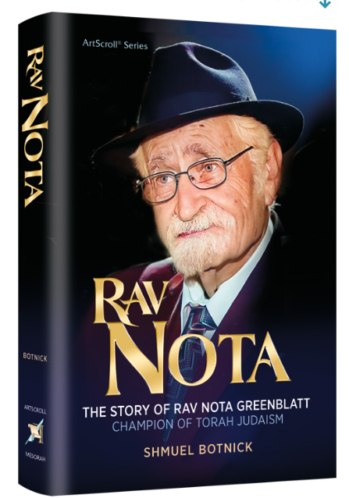

There was something unique about the relationship between Rav Moshe Feinstein and Rav Nota Greenblatt. The mutual love they had for each other can only be described as that of father and son. This, in fact, is the precise description that Rav Moshe himself used on multiple occasions. In the countless letters that Rav Moshe sent to Rav Nota over the years, the opening line would be a greeting and a blessing, often referring to him as “yakar v’chaviv li k’bni (as precious and dear to me as my son).”
“We took daily walks, along the East River or the Hudson River,” Rav Nota recalled. “Rav Moshe told me things that he never told anyone. He told me about the first time he finished Shas! He said it was in his early teens — he couldn’t recall his age exactly, but he said that the date was the fourth of Adar.”
Rav Nota spent several years in Mesivta Tiferes Yerushalayim, studying under Rav Moshe from 1942 until 1945. During this time, the two grew incredibly close and Rav Nota spent much time in the Feinstein home, where the phone rang incessantly with a plethora of halachic questions.
It was his responsibility to answer the phone and present the questions to Rav Moshe. But at some point, Rav Moshe appointed Rav Nota to take on a role that was more than clerical.
“If you know the answer to the question,” said Rav Moshe, “answer it yourself. If you can’t answer it yourself, come to me.”
An interesting dialogue once resulted from that arrangement. The phone rang and Rav Nota picked up. The caller — who spoke with a rich Polish accent but did not mention his name — asked to speak with Rav Moshe.
“Rav Moshe is not available,” said Nota. “What’s your question?”
The caller demurred, explaining that he really wanted to speak with Rav Moshe.
“Try me out,” said Nota. “If I don’t have the answer, I’ll ask Rav Moshe.”

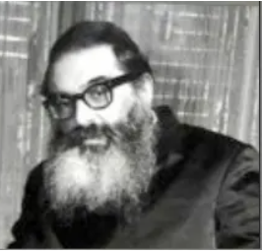
Rav Yitzchak Hutner

The man wasn’t giving in easily. “What’s your name?” he wanted to know. “Greenblatt.”
“How old are you?”
“Nineteen.”
“Are you married?”
“No.”
“Okay, I’ll ask you the question.” The fellow went on to describe his question and nineteen-year-old Rav Nota rattled out a rapid response.
“Ze’ir gut, very good,” said the caller, and then, “Zug Rav Moshe az Hutner hut gerufen — Tell Rav Moshe that Hutner called.”
It was none other than Rav Yitzchak Hutner, the legendary rosh yeshivah of Yeshivas Rabbeinu Chaim Berlin. The following day, the phone in Rav Moshe’s home rang again. It was the same familiar voice. This time, however, he did not request to speak with Rav Moshe. “Iz Greenblatt duh? Is Greenblatt there?” Rav Hutner wanted to know.
Rav Nota took the phone and the two discussed various topics in halachah. The same thing repeated itself for the next several days and Rav Nota developed somewhat of a relationship with Rav Hutner.

Reprinted from the Parshas Vayechi 5784 edition of At the ArtScroll Shabbos Table. Excerpted from the ArtScroll book – “Rav Nota – The Story of Rav Nota Greenblatt.”

The Gift of Anivas (Humility)

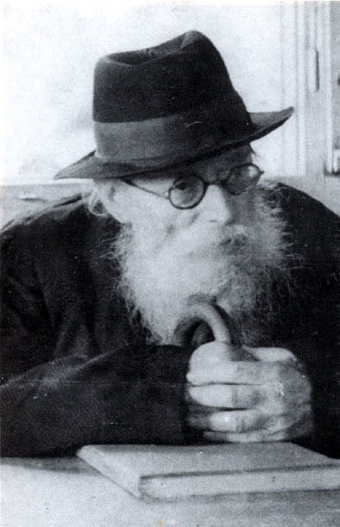
The Chazon Ish

As a young man, Rav Elyakim Schlesinger of London, a Talmid of the Brisker Rav, zt”l, served the Chazon Ish, zt”l. One time, he built up the courage to ask the Chazon Ish if he knew that he was the Gadol HaDor.
The Chazon Ish thought for a moment and then replied that he was aware of his role and responsibility as the Gadol HaDor. When the young Rav Elyakim asked how the Chazon Ish balanced that awareness with the Middah of Anivus.
The Chazon Ish explained, “Humility does not require one to deny his abilities. Rather, one must appreciate the talents Hashem has given him and realize what he has. Anivus helps one attribute those gifts to Hashem.”
The Chazon Ish concluded, “I am certain that if someone else would have been given the gifts I was given, he too would have become the Gadol HaDor!”
In his later years, the Steipler Gaon, Rav Yaakov Yisroel Kanievsky, zt”l, would give his annual Shiur, in memory of his brother-in-law, the Chazon Ish, to an assembly of thousands of people.
One evening, following a Shiur that had an unusually large crowd, the Steipler, in his great humility, said, “It is only because the Shiur is given once a year that I have such a large crowd. If I were to give this Shiur on a weekly basis, I would be lucky to have a Minyan to say Kaddish D’Rabbanan after!”
Another episode, of many, also reflected the humility of the Steipler. One Purim, an especially large group of young children were brought by their parents to visit the Steipler Gaon to receive a Brachah. The Steipler commented, “The large crowd is the result of their day off from Cheder. Children are home, and the mothers have to occupy them with something to do. The easiest thing is to bring them to an old man for a Brachah!”

Reprinted from the Parshas Vayeitzei 5784 email of Rabbi Yehuda Winzelberg’s Torah U’Tefilah.

Calm Down!
By Aharon Spetner

A young man burst into the offices of Holtzbacher Enterprises. “Hello,” he said to the receptionist. “My name is Aharon Horowitz. I need to meet with Mr. Holtzbacher right away.”
The receptionist looked down at a sheet of paper on his desk. “Hmm,” he said, tapping his fingers on his desk. “I don’t see you on his schedule. Are you sure your appointment is for today?”
“Oh I don’t have an appointment,” said Aharon. “I just need to see him right away - it’s very important!”
Just then a door opened and Anshel Holtzbacher stepped out of his office.
“Mr. Holtzbacher!” Aharon exclaimed. “Please give me just five minutes of your time!”
“This is Aharon Horowitz,” the receptionist said. “He says he has something very important to discuss with you.”
Anshel Holtzbacher looked at Aharon and then at his watch, and then back at Aharon. “Alright, come into my office. But just five minutes.”
Aharon followed Anshel into his large, ornate office. “Okay, Aharon,” Anshel said. “What did you want to discuss?”
“I have an amazing business opportunity for you,” Aharon said quickly, opening up his boxes and pulling out a small object. “Look at this pyramid - isn’t it beautiful?”
“Uh - it’s very nice,” Anshel said. “But what’s your idea?”

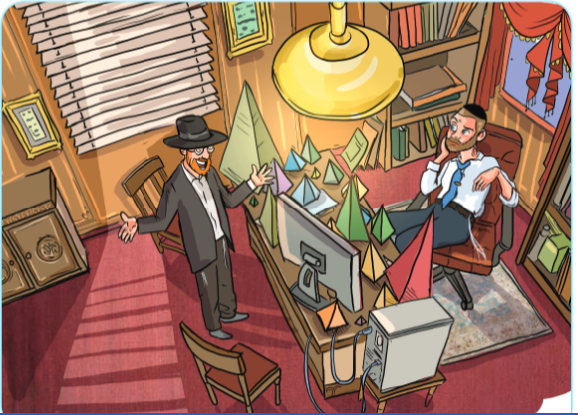
Illustrated by Miri Weinrib

“We’re going to sell them!” Aharon said, full of excitement, as he began to unpack his boxes, placing pyramids of various sizes on Anshel’s desk.
“I’m not sure I’m understanding,” Anshel said.
“It’s simple,” Aharon said. “Everyone loves pyramids, right?”
Anshel frowned, as Aharon continued.
“So, my new business is going to be called Pyramid of Pyramids. And the way it works is people pay me $100 to sign up and they receive a free pyramid. Then, if they get other people to sign up, those people pay $100 and each get a pyramid. For each sign-up that a person brings in, he gets $10. If he signs up ten people, he gets an even bigger pyramid. If he signs up a hundred people, he gets this large pyramid, and if he signs up a thousand people, he gets a giant pyramid like this one over here - isn’t it gorgeous? And this way, everyone who joins gets free beautiful pyramids and they all make a lot of money - we won’t have any more poor people, because everyone will be rich!”
“Ummm... I’m not sure this is a good idea,” Anshel said.
“Of course, it is!” Aharon said, pacing the room rapidly. “I took all of the money from my chasunah presents and invested it in these prototype pyramids. All I need is a five-million-dollar investment from you so I can make enough pyramids for everyone, and you’ll get a 25% share in the company, and I’ll be able to learn in kollel for the rest of my life! What could possibly go wrong?”
“Aharon, please have a seat,” Anshel said.
Aharon stopped pacing and sat down.
“Listen,” said Anshel. “What you’re describing is a ‘pyramid scheme’, and it’s illegal.”
“Why is it illegal to sell pyramids?” asked Aharon.
“It has nothing to do with pyramids. But this idea of getting people to give you money to sign up and then have them sign up more people and make money from them instead of from selling products is known as a ‘pyramid scheme’. It’s against the law.”
“I didn’t mean to break the law,” Aharon said, suddenly nervous.

You Didn’t Break the Law Yet
“Well, you didn’t yet, boruch Hashem,” said Anshel. “But I want to bring up something else. In this week’s Parsha, Yaakov Avinu gives his sons brachos. But it starts off with him telling Reuven off for rushing into something without thinking it through. How do we understand that? He was giving brachos, not klalos. So why did he curse Reuven’s middah of being too hasty?”
Aharon looked at the floor. “I think I see where this is going,” he mumbled.
“Aharon,” said Anshel. “You seem like a very bright young man. But I want you to think about what just happened. You rushed into an idea without thinking it through, and spent all of your savings in the process. Don’t you think it would have made sense to speak to me or someone else about it first?”
“Yes,” said Aharon, still looking at the floor.
“Listen,” Anshel said. “I happen to know an art dealer who would be very happy to buy these pyramids off of you so you can get your money back. But I want you to promise me to be more careful in the future and not rush into things without giving them proper thought and consideration.”
Aharon’s face lit up. “Really? Thank you so much! And thank you so much for teaching me a valuable lesson!”
Have A Wonderful Shabbos!
Takeaway:
Rushing into things is not a good middah.
A Yid should always think things through in a calm manner.
Reprinted from the Parshas Vayechi 5784 email of Toras Avigdor Junior, adapted from the teachings of Rav Avigdor Miller, zt”l.

